**Appendix F**

**Scrum**

* 1. **Black Bear Bank - Sprint 3 - Elaboration**

Sprint Dates: 21 April, 22 April, 25 April

Nr of points for this sprint: 290

|  |  |  |  |  |  |
| --- | --- | --- | --- | --- | --- |
| Task | Story Points | Status | Day 1 | Day2 | Day3 |
| Document progress made during Sprint 2 | 25 | Done |  |  | 25 |
| Create non-functional requirements | 20 | Done | 20 |  |  |
| Create use case diagram | 15 | Done | 15 |  |  |
| Create the first 5 use case descriptions | 20 | Done | 13 | 7 |  |
| Create the next last 5 use case descriptions | 20 | Done | 5 | 15 |  |
| Create activity diagrams for the first 5 use cases | 10 | Done |  | 10 |  |
| Create activity diagrams for the last 5 use cases | 10 | Done |  | 6 | 4 |
| Update use case diagram | 5 | Done |  | 5 |  |
| Create System Sequence Diagrams for most of the use cases | 15 | Done |  | 10 | 5 |
| Create a domain model | 20 | Done | 20 |  |  |
| Create Register GUI Window | 15 | Done |  | 12 | 3 |
| Update 'Register an account' use case and afferent diagrams | 5 | Done |  |  | 5 |
| Create LogIn GUI Window | 15 | Done |  |  | 15 |
| Start designing Server |  | Done |  |  |  |
| Start designing Client-Side class diagram respecting MVVM design pattern | 25 | Done | 5 | 15 | 5 |
| Starting to create MVVM structure | 15 | Done |  | 10 | 5 |
| Update domain model | 5 | Done |  |  | 5 |
| Test Login and Register Window GUI functionality | 10 | Done |  |  | 10 |
| Create ER diagram | 20 | Done |  |  | 20 |
| Design TCP Socket Client and Server connection | 20 | Done |  | 5 | 15 |
| Total | 290 | Done | 78 | 95 | 117 |
| Scrum Master's approval : | | |  |  | Done |

# 

* 1. **Black Bear Bank - Sprint 4 - Construction**

Sprint Dates : 27 April , 28 April, 30 April

Nr of points for this sprint :415

|  |  |  |  |  |  |
| --- | --- | --- | --- | --- | --- |
| Task | Story Points | Status | Day 1 | Day2 | Day3 |
| Document development performed during Sprint 4. | 25 | Done |  |  | 25 |
| Patch all the bugs found testing the Register and LogIn GUI Windows | 20 | Done | 15 | 5 |  |
| Create Client GUI Window | 30 | Done | 15 | 10 | 5 |
| Test all the functionality of Client GUI Window | 20 | Done |  | 5 | 15 |
| Patch all the bugs found testing the Client GUI Window | 20 | Done |  | 5 | 15 |
| Create SQL Database | 25 | Done | 15 | 10 |  |
| Finish designing the server side | 15 | Done |  | 10 | 5 |
| Start implementing server | 30 | Done | 20 | 10 |  |
| Connect DataBase to server | 15 | Done |  | 15 |  |
| Improve GUI design for LogIn and Register Windows | 10 | Done |  | 5 | 5 |
| Update 'Manage funds accounts' use case and afferent diagrams | 10 | Done |  | 5 | 5 |
| Implement the TCP Sockets connection between the Server and Client-sides | 20 | Done | 10 | 10 |  |
| Implement the Server Client Handlers | 10 | Done | 5 | 5 |  |
| Update Domain Model | 5 | Done | 5 |  |  |
| Update ER Diagram | 5 | Done | 5 |  |  |
| Implement the LogIn Window functionality on the server | 15 | Done |  | 15 |  |
| Implement the Register Window functionality on the server | 15 | Done |  | 15 |  |
| Update the Register GUI Window | 5 | Done |  | 5 |  |
| Test the LogIn and Register functionality and patch the bugs found | 10 | Done |  |  | 10 |
| Implement exchange rates and update the ER Diagram and Domain Model | 15 | Done |  |  | 15 |
| Implement the Client Window functionality on the server | 25 | Done |  | 15 | 10 |
| Implement automatic account deletion functionality on the Server side | 10 | Done |  |  | 10 |
| Add a clock to the Client Window GUI | 10 | Done |  |  | 10 |
| Add custom descriptions to accounts and update appropiata use cases and diagrams | 10 | Done |  | 5 | 5 |
| Update the color-scheme of all of the GUI windows | 10 | Done |  |  | 10 |
| Test all of the Client windows functionality and patch the bugs | 15 | Done |  | 5 | 10 |
| Adding the ability to transfer bethween own account and updating the use cases and diagrams | 15 | Done |  | 10 | 5 |
| Total | 415 | Done | 90 | 165 | 160 |
| Scrum Master's approval : | | |  |  | Done | |

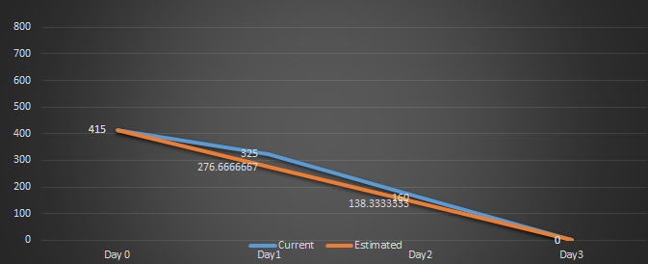

* 1. **Black Bear Bank - Sprint 5 - Construction**

Sprint Dates : 4 May , 5 May, 7 May

Nr of points for this sprint : 440

|  |  |  |  |  |  |
| --- | --- | --- | --- | --- | --- |
| Task | Story Points | Status | Day 1 | Day2 | Day3 |
| Document development performed during Sprint 5 | 25 | Done |  |  | 25 |
| Implement the Staff Client Handler on the Server | 15 | Done | 15 |  |  |
| Implement the Staff GUI Window using the Client Window as a model | 25 | Done | 20 | 5 |  |
| Test the functionality of the Staff GUI Window | 15 | Done | 5 | 10 |  |
| Update the LogIn Client handler to support Staff or Manager types | 10 | Done | 10 |  |  |
| Update the LogIn GUI Window to open the Staff Window when needed | 10 | Done | 10 |  |  |
| Update the 'Manage Exchange Rates' use case and diagrams | 15 | Done |  | 15 |  |
| Add conditions to the user input of the Client window | 10 | Done | 10 |  |  |
| Add Confirm windows to all of the actions of the Cllient and Staff GUI windows | 10 | Done |  |  | 10 |
| Change the XML file styling the program tables | 5 | Done |  | 5 |  |
| Add icons to the buttons of the Client and Staff GUI windows | 10 | Done |  |  | 10 |
| Update the styling of the GUI | 20 | Done | 5 | 5 | 10 |
| Add the ability to change the staff member password | 15 | Done |  | 15 |  |
| Add the ability to change client password | 15 | Done |  | 15 |  |
| Update the use cases and afferent diagrams | 30 | Done |  | 5 | 25 |
| Check all the programs functionality and patch the bugs | 40 | Done |  | 30 | 10 |
| Create test cases documentation | 25 | Done | 10 | 15 |  |
| Update the class diagrams according to the code | 50 | Done |  |  | 50 |
| Start composing digital scrum documentation | 30 | Done | 15 | 15 |  |
| Improve server realiability | 35 | Done | 5 | 15 | 15 |
| Improve clock hit on performance | 10 | Done | 10 |  |  |
| Update the sequence diagrams | 20 | Done | 10 | 10 |  |
| Total | 440 | Done | 125 | 160 | 155 |
| Scrum Master's approval : | | |  |  | Done |

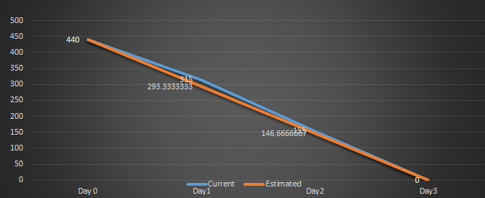

* 1. **Black Bear Bank – Sprint 6 – Transition**

Sprint Dates : 11 May , 12 May, 15 June

Nr of points for this sprint : 370

|  |  |  |  |  |  |
| --- | --- | --- | --- | --- | --- |
| Task | Story Points | Status | Day 1 | Day2 | Day3 |
| Improve GUI. | 30 | Done | 30 |  |  |
| Check Scrum documentation. | 50 | Done | 50 |  |  |
| Check use cases and diagrams. | 50 | Done | 40 | 10 |  |
| Create Process Report. | 120 | Not done |  |  | 40 |
| Create Project Report. | 120 | Done | 50 | 50 | 20 |
| Total | 370 |  | 170 | 60 | 60 |
| Scrum Master’s approval : |  |  |  |  | Not done |

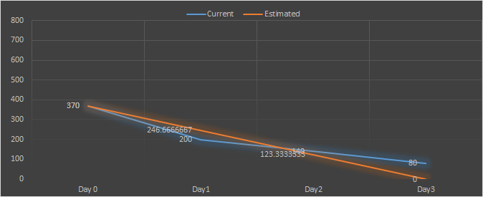

* 1. **Black Bear Bank - Sprint 7 - Transition**

Sprint Dates :18 May, 19 May, 20 May

Nr of points for this sprint : 210

|  |  |  |  |  |  |
| --- | --- | --- | --- | --- | --- |
| Task | Story Points | Status | Day 1 | Day2 | Day3 |
| Check use cases and diagrams | 50 | Done | 50 |  |  |
| Create user guide for application | 30 | Done | 30 |  |  |
| Finish Process Report | 80 | Done | 60 | 20 |  |
| Check everything once again | 50 | Done |  |  | 50 |
| Total | 210 | Done | 140 | 20 | 50 |
| Scrum Master's approval : |  |  |  |  | Done |

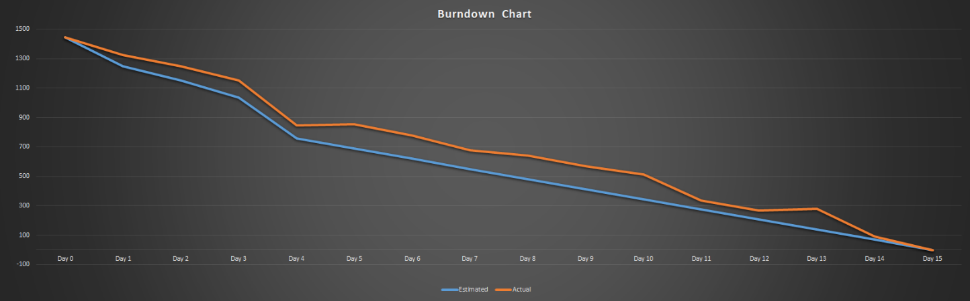  
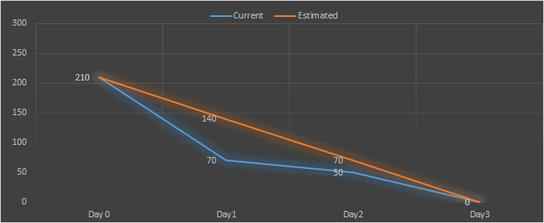  
  
**Burndown chart:**